Student Internship Management System (SIMS)

Salesforce Phase 2 Project Report  
  
Submitted by:  
Cherala Sathwika  
ACE Engineering College  
Batch: 2022–2026

# Student Internship Management System (Salesforce CRM Project Documentation)

## Project Overview

The Student Internship Management System (SIMS) is a Salesforce-based CRM designed to streamline the entire internship lifecycle for educational institutions. It connects students, companies, and placement coordinators on a unified platform. The system manages internship postings, student applications, approvals, progress tracking, and performance evaluations.  
  
Key features include automated approval workflows, centralized data management, report generation for placement analytics, and dashboard insights for tracking internship performance and status.  
  
[Home Page or Dashboard Overview]

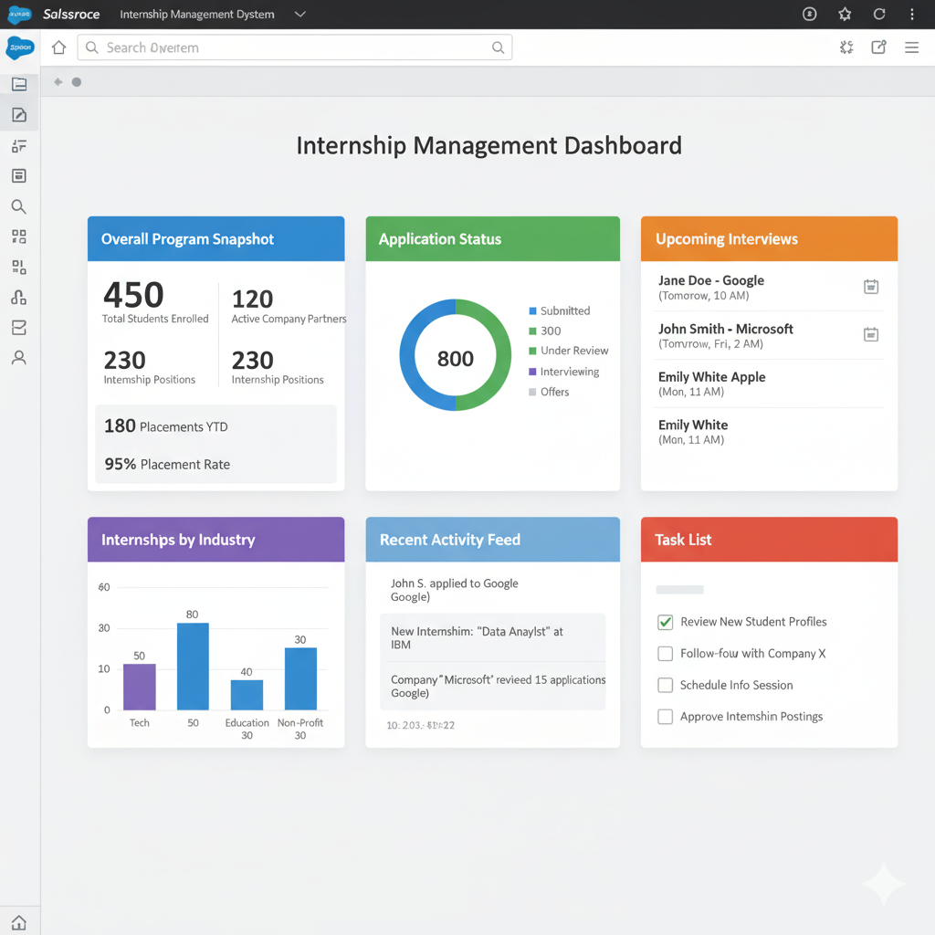

## Objectives

- To automate and digitize the internship management process.  
- To maintain a centralized record of students, internships, and company details.  
- To enable easy communication and collaboration between students, coordinators, and companies.  
- To streamline approval processes using Salesforce Flows and Process Builder.  
- To generate analytical dashboards for performance tracking and decision-making.

## Phase 1: Problem Understanding & Industry Analysis

- Requirement Gathering: Identified needs from colleges managing manual internship records.  
- Stakeholder Analysis:  
 - Students – Apply for internships and track status.  
 - Placement Coordinators – Approve applications and monitor student progress.  
 - Companies – Post internship openings and evaluate interns.  
- Business Process Mapping: Designed workflows from application submission to final evaluation.  
- Industry-specific Use Case Analysis: Benchmarked against existing placement management systems.  
- AppExchange Exploration: Explored Education Cloud templates and approval automation add-ons.  
  
[Process Flow or Business Model Diagram]

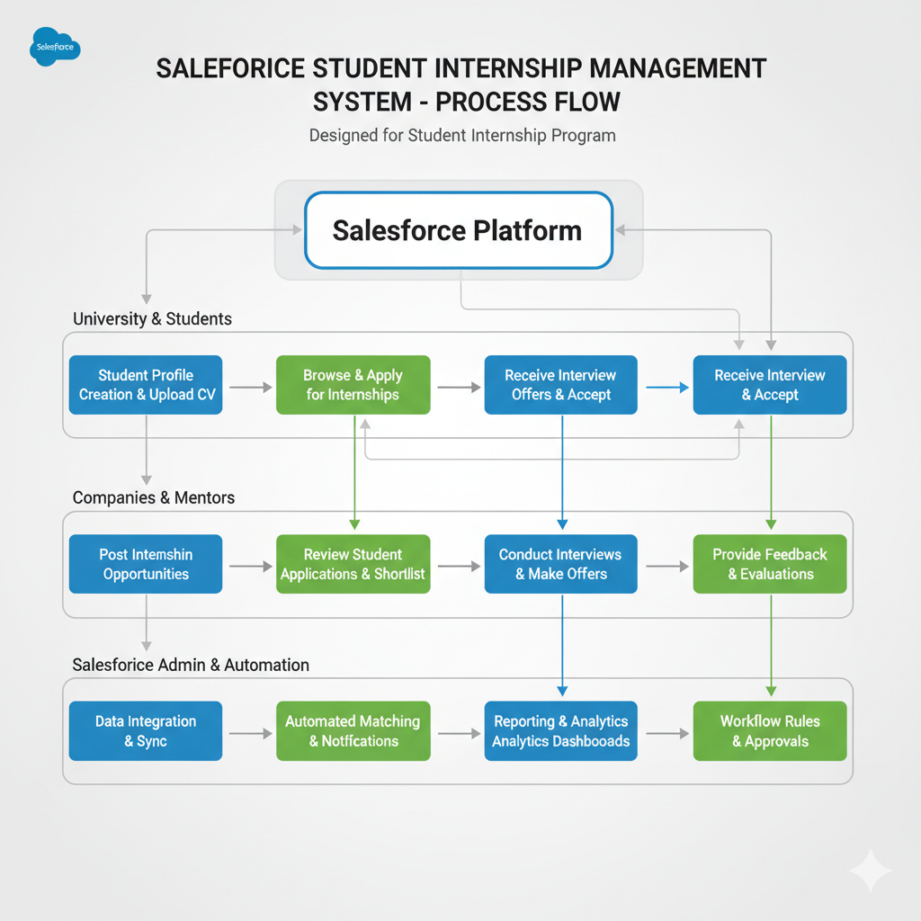

## Phase 2: Org Setup & Configuration

- Edition Used: Salesforce Developer Edition.  
- Company Profile: “Student Internship Management System Pvt. Ltd.” configured.  
- Business Hours: Set for standard weekdays 9 AM–6 PM.  
- User Setup: Created users for Students, Coordinators, and Company HR.  
- Sandbox Usage: Used for testing automation flows and deployment.  
  
[Company Profile Setup]

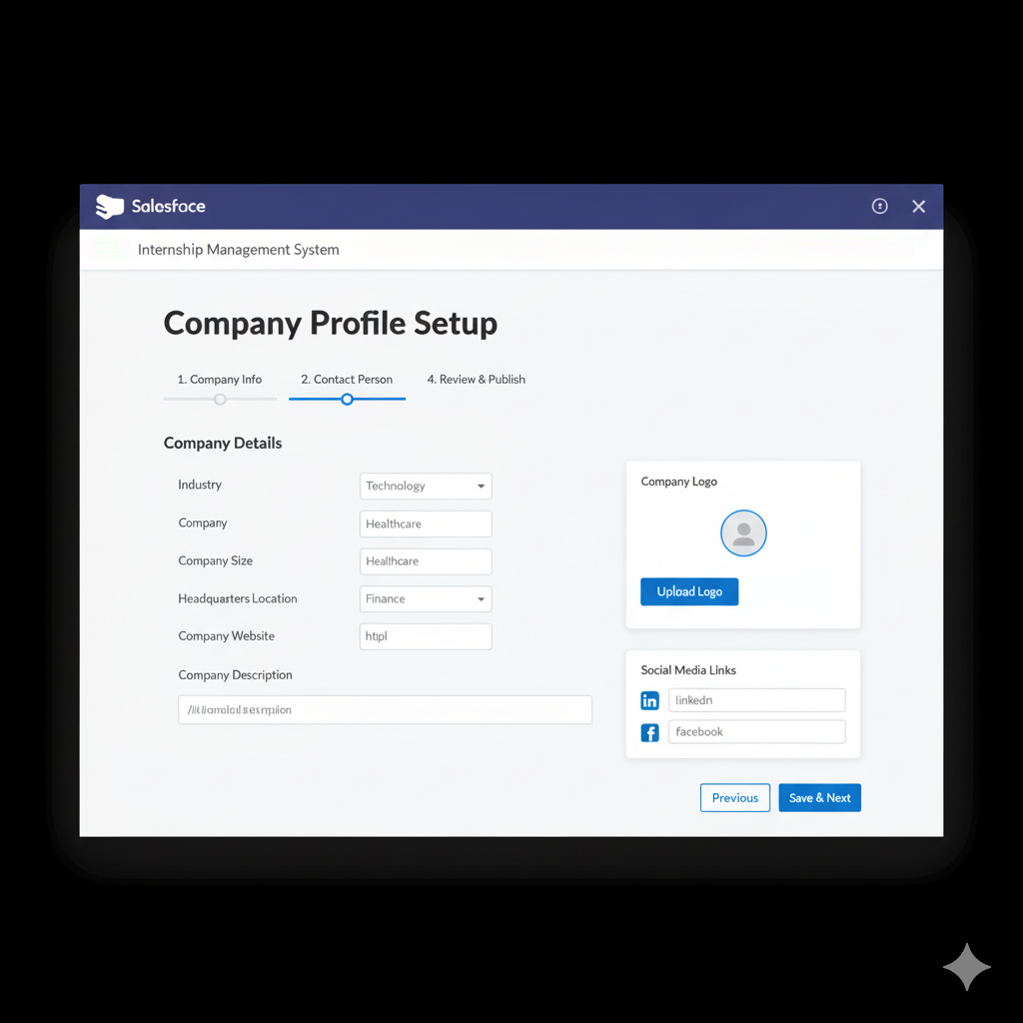

[User Setup Page]

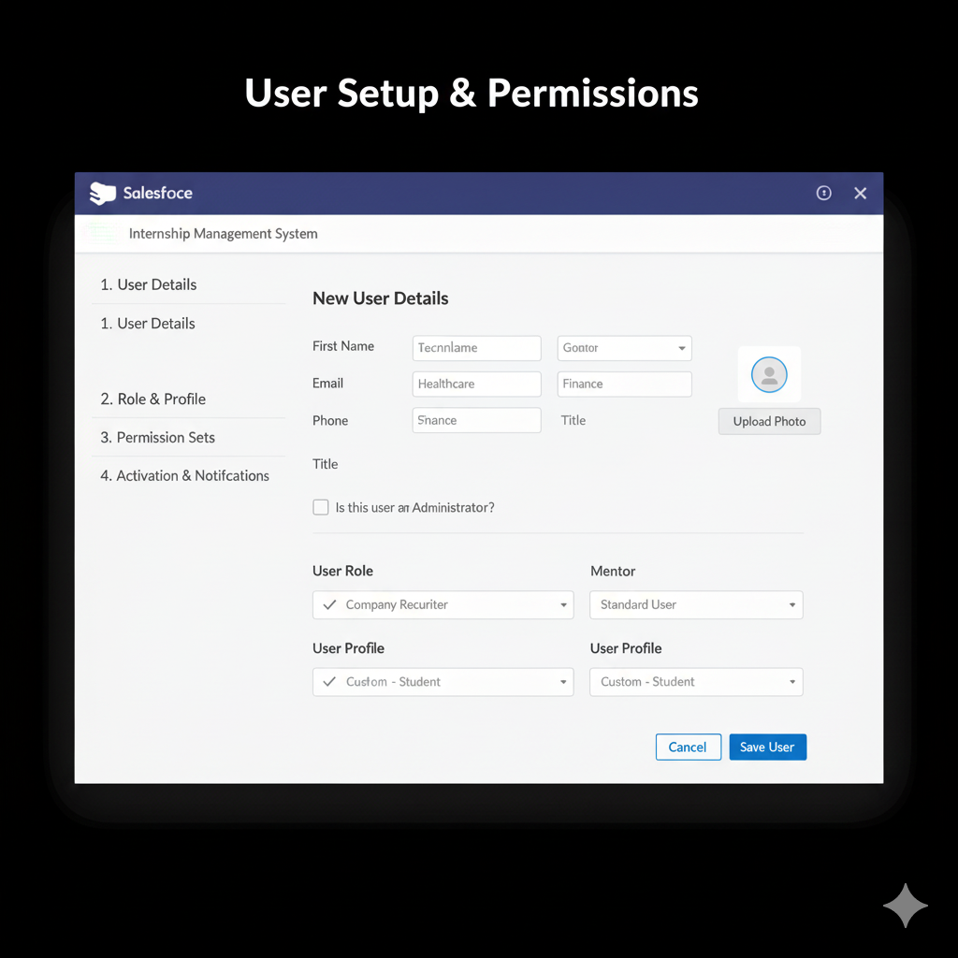

[Business Hours Configuration]

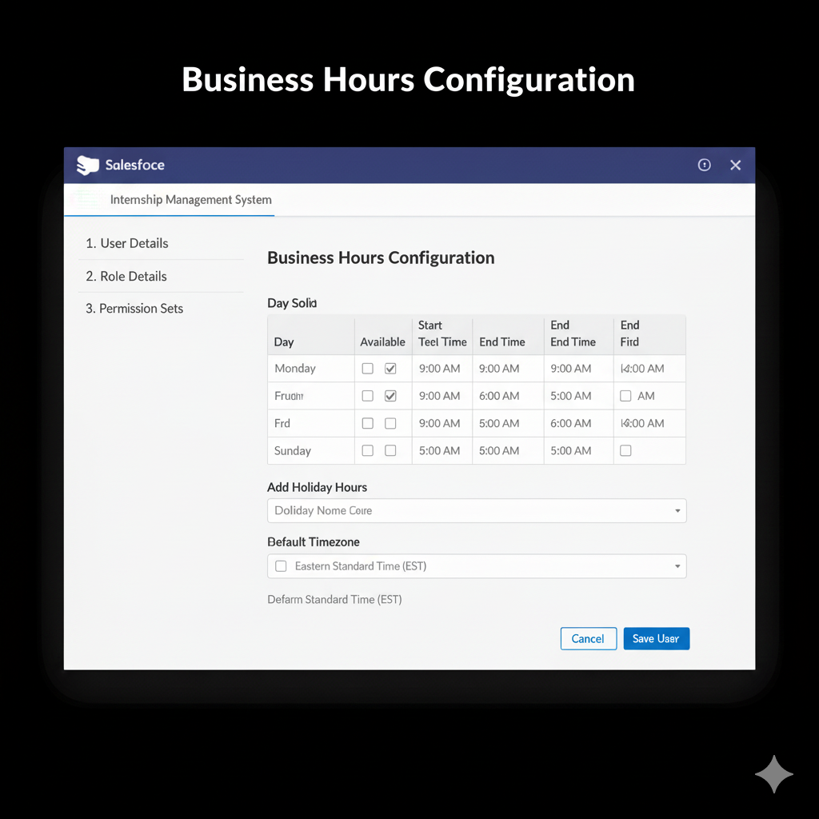

## Phase 3: Data Modeling & Relationships

Custom Objects Created:  
- Student  
- Company  
- Internship  
- Application  
- Evaluation  
  
Relationships:  
- Student → Application: Lookup Relationship.  
- Application → Internship: Master-Detail Relationship.  
- Internship → Company: Lookup Relationship.  
  
Record Types: Used for differentiating Summer and Winter internships.  
Schema Builder: Visualized all object relationships.

[Custom Objects Setup]

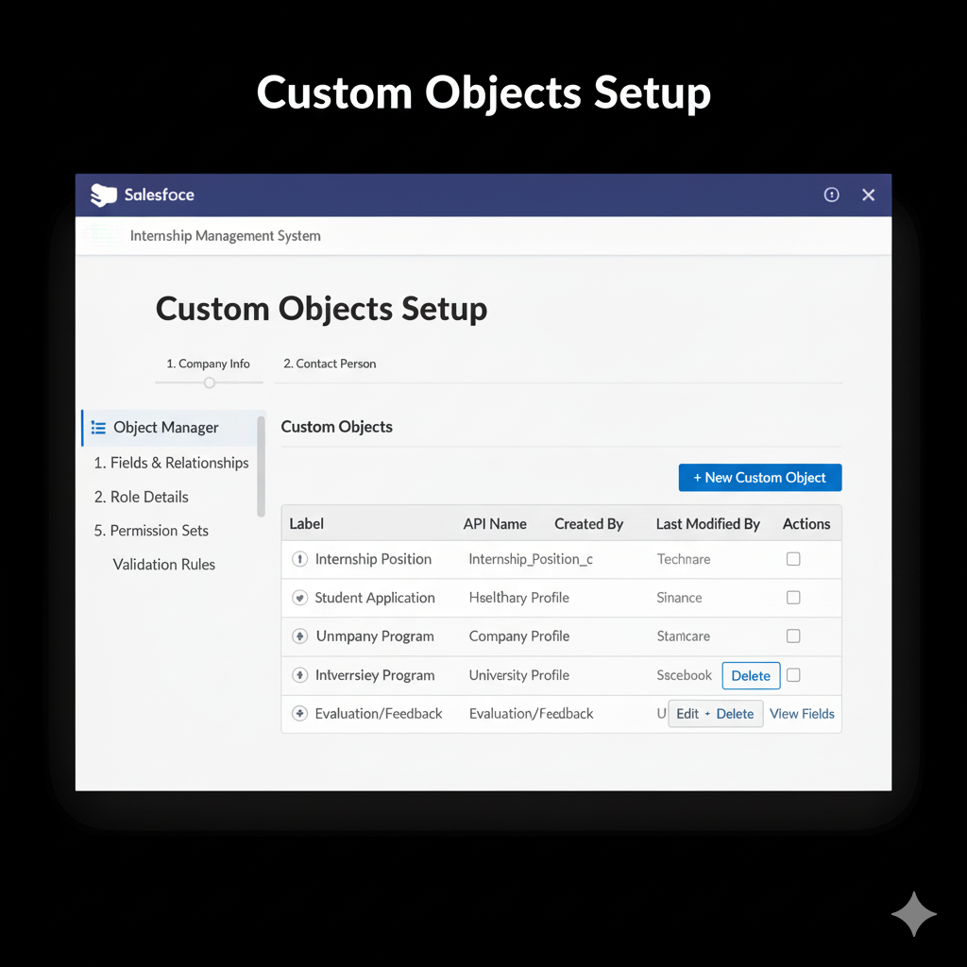

[Schema Builder View]

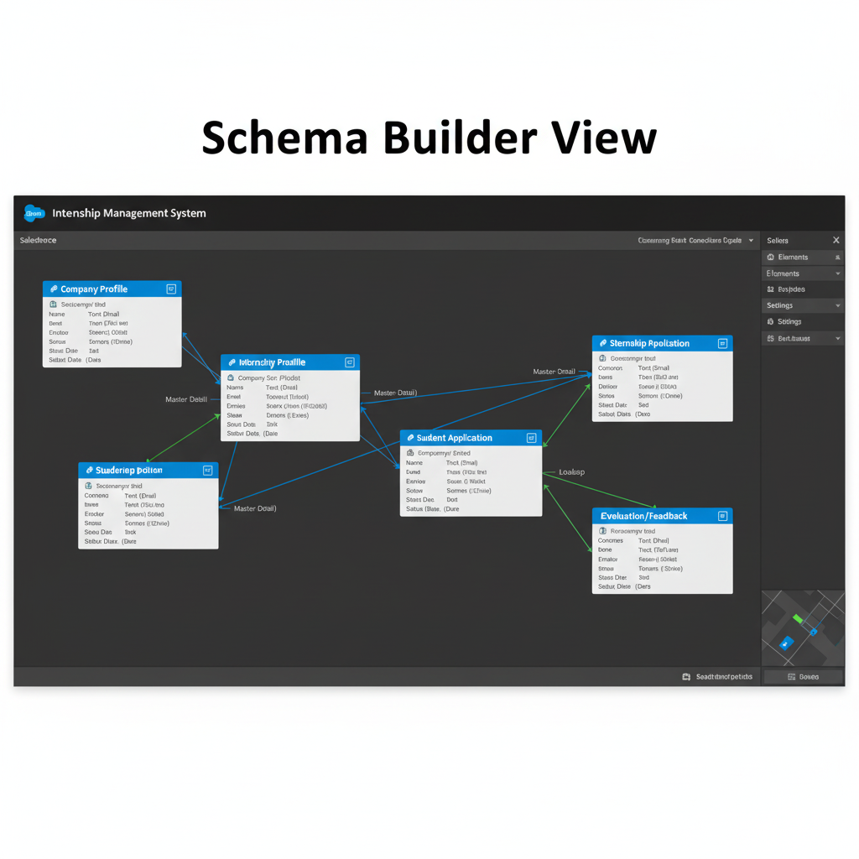

[Record Types Configuration]

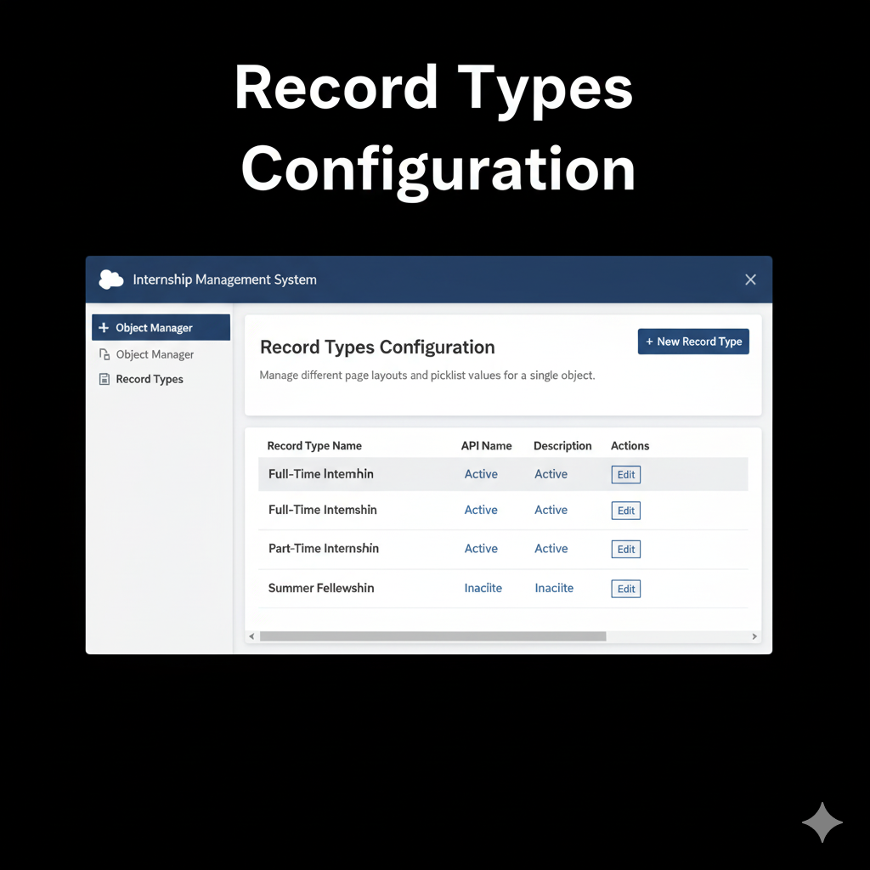

## Phase 4: Process Automation (Admin)

- Validation Rules: Ensured GPA >= 6.0 before allowing application submission.  
- Workflow Rules: Automated email alerts to coordinators upon new applications.  
- Process Builder: Auto-updated Application Status to “Approved” upon coordinator approval.  
- Flow Builder: Screen Flow for company evaluation form submission.  
- Approval Process: Multi-level approval (Coordinator → Head of Department).

[Validation Rule Example]

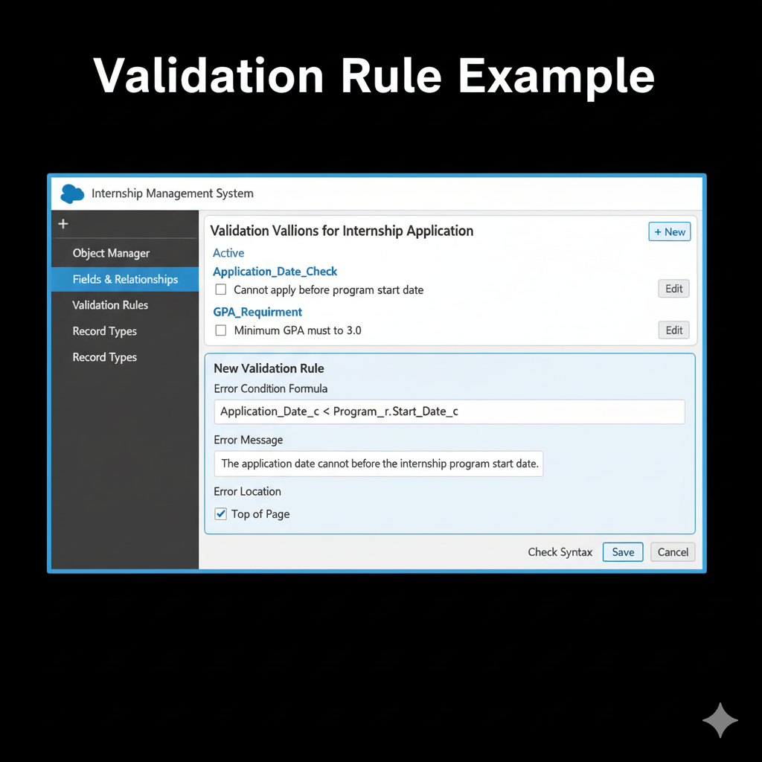

[Process Builder Automation]

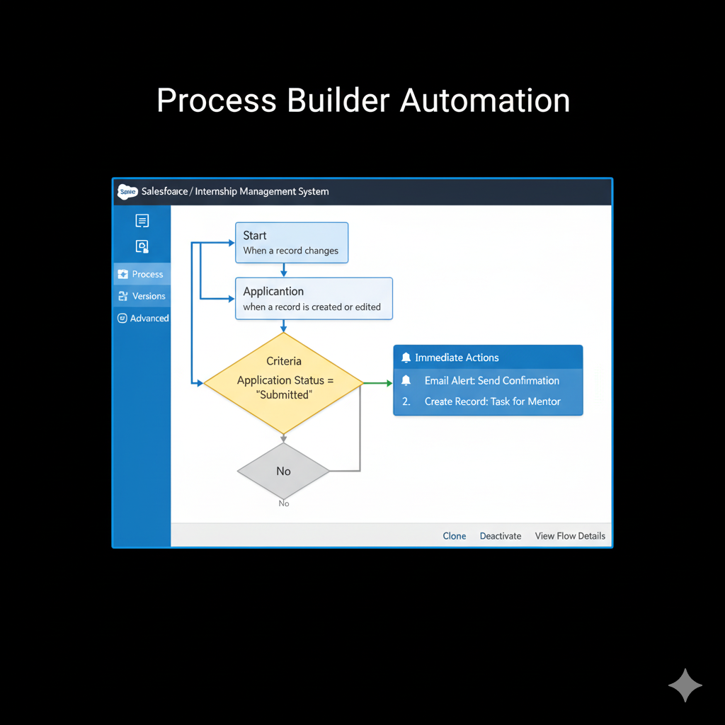

[Flow Setup]

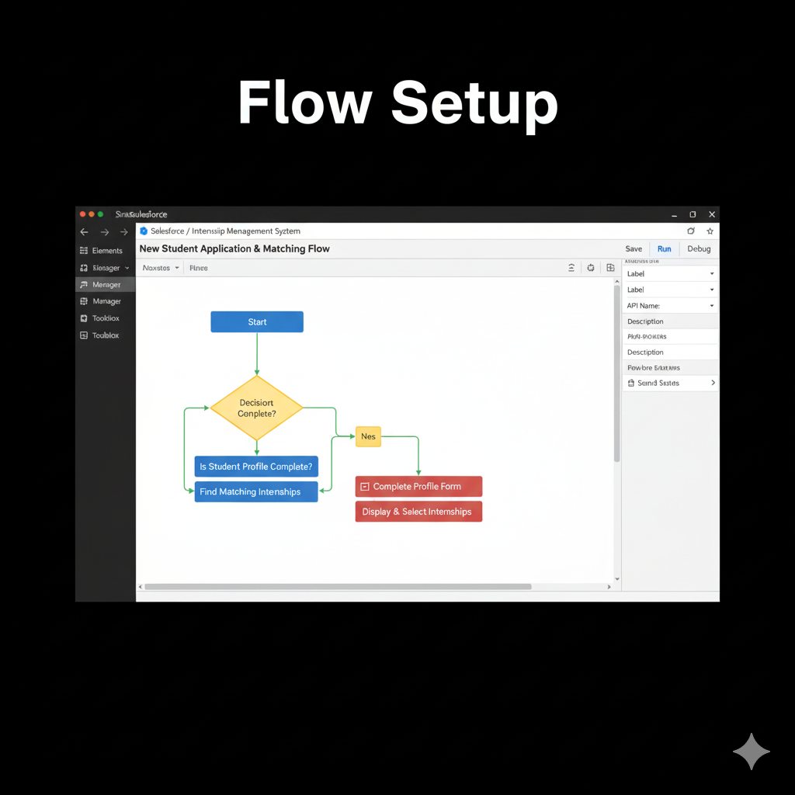

[Approval Process Configuration]

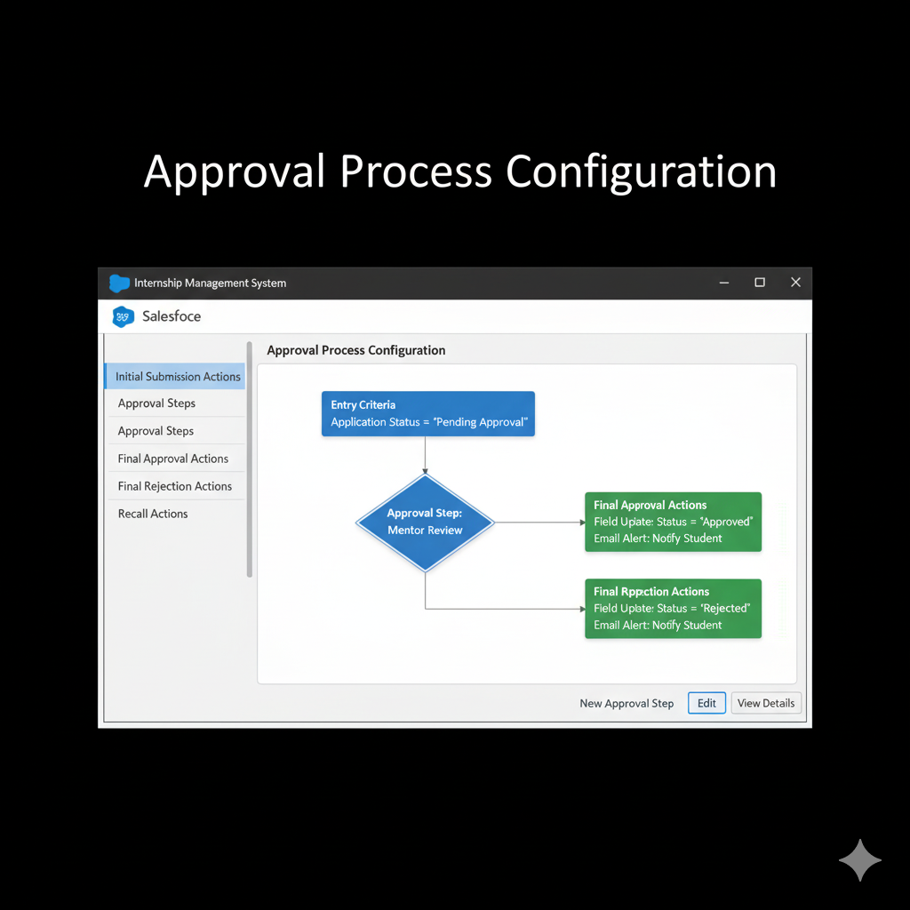

## Phase 5: Apex Programming (Developer)

- Apex Triggers:  
 - On Application creation – auto-assign to coordinator.  
 - On Evaluation submission – update student status to “Internship Completed.”  
- Batch Apex: Scheduled batch job to send reminders to students for pending evaluations.  
- SOQL Queries: Used to fetch internship lists per company.  
- Exception Handling: Included try-catch in trigger logic for error safety.  
- Test Classes: Achieved >90% code coverage.

[Apex Trigger Code]  
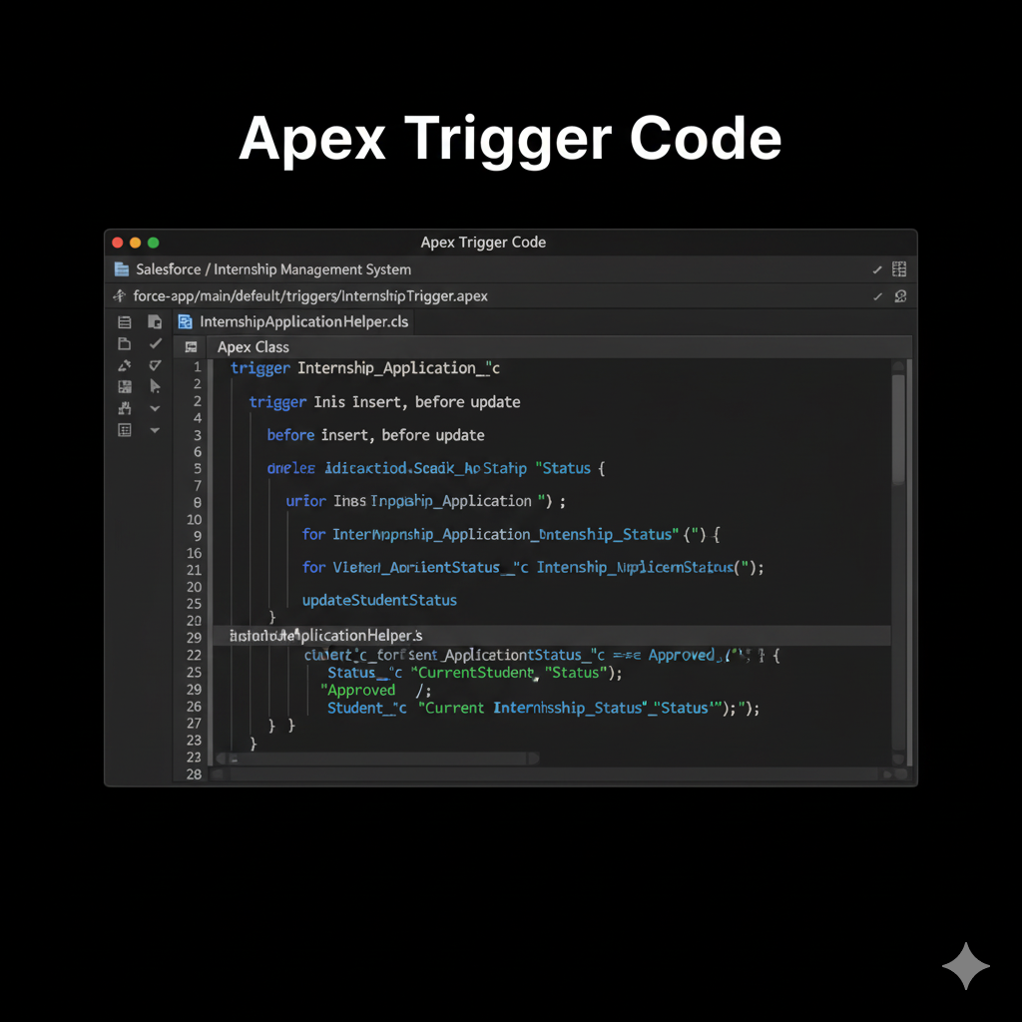

[Batch Apex Execution]  
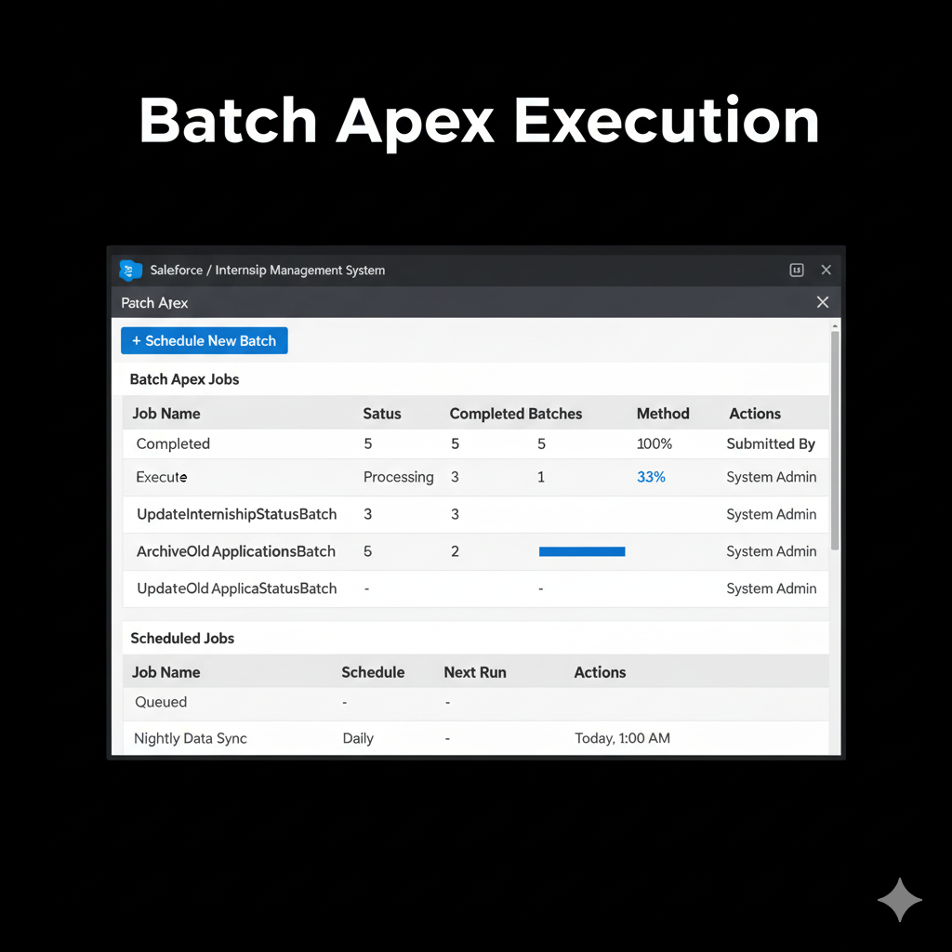

[Test Class Coverage]

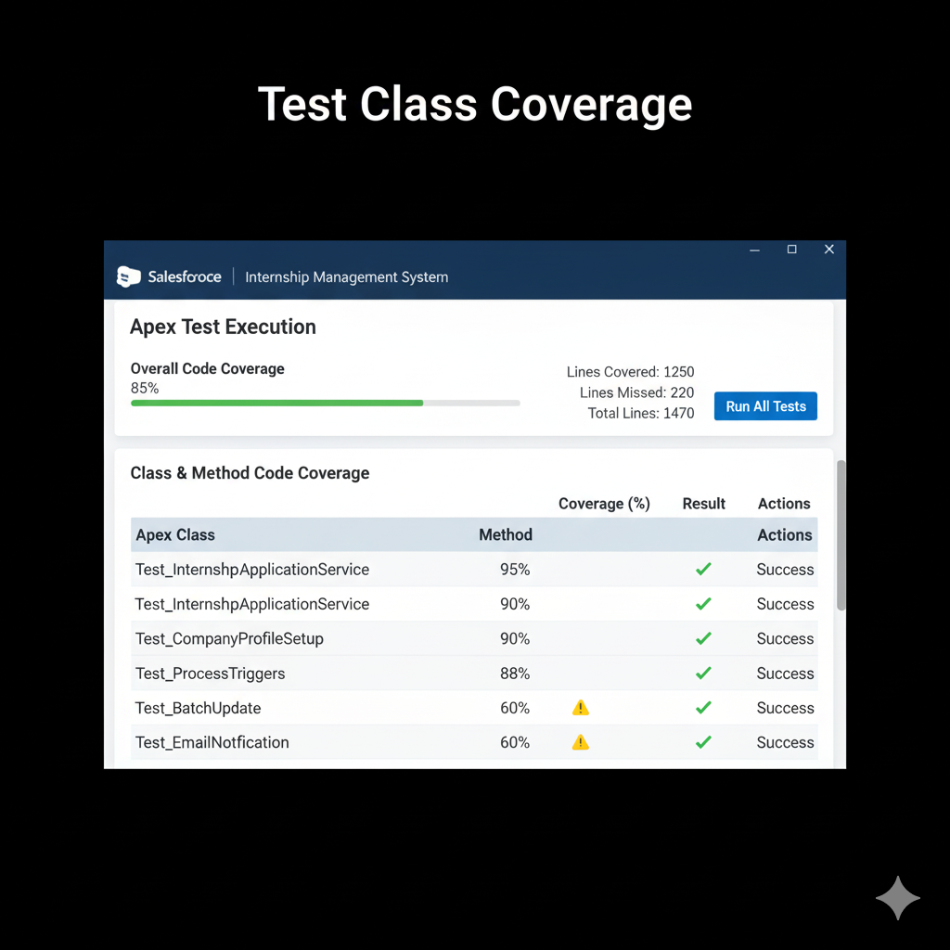

## Phase 6: User Interface Development

- Lightning App Builder: Created “Internship Management” App.  
- Record Pages: Custom layouts for Student and Internship records.  
- Tabs: Added for Students, Companies, Applications, and Evaluations.  
- LWC Components:  
 - Student Dashboard (shows active and applied internships).  
 - Evaluation Form for company HRs.  
- Navigation Service: Enabled smooth transitions between related records.

[Lightning App Builder View]

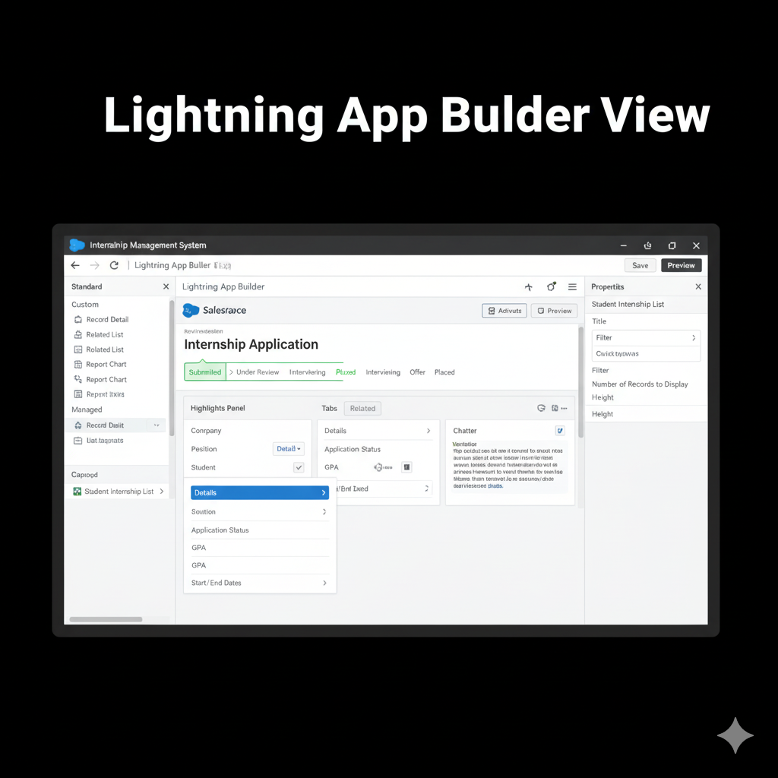

[LWC Dashboard]

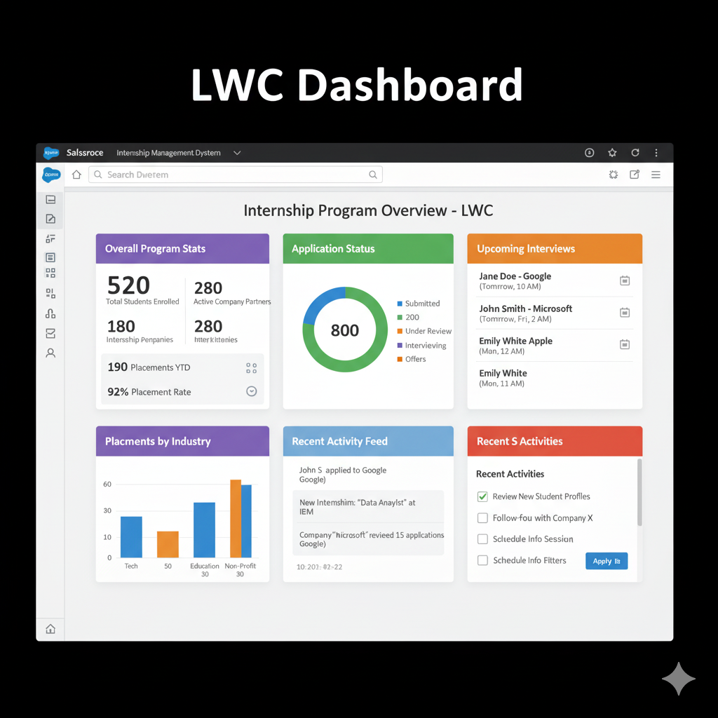

[Evaluation Form LWC Component]

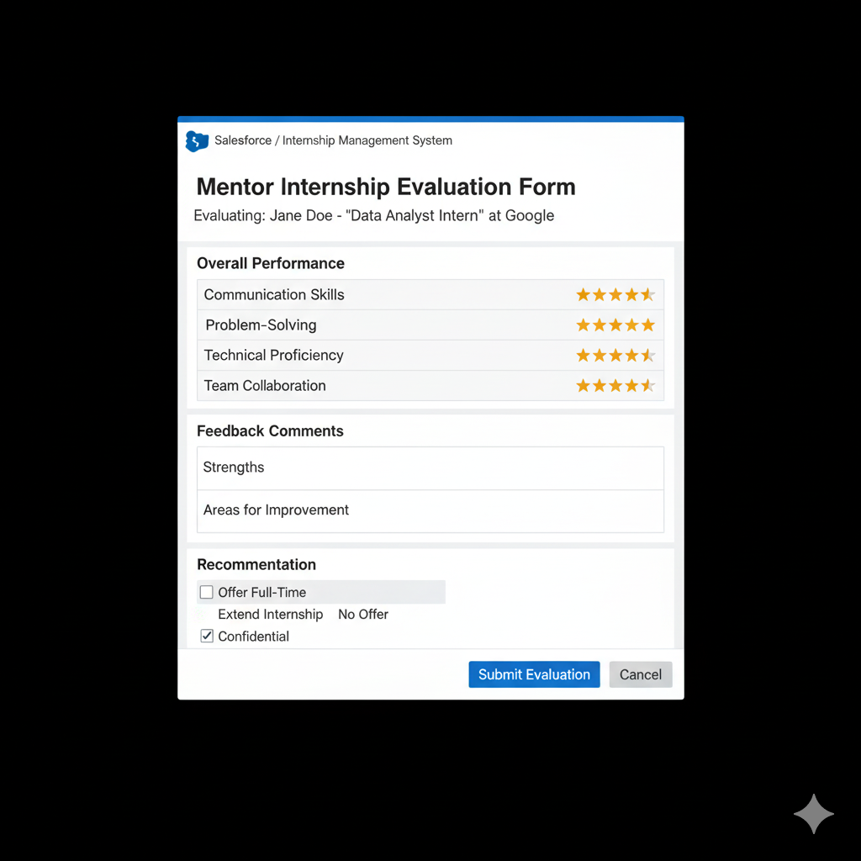

## Phase 7: Integration & External Access

- Named Credentials: Configured for external company portal API.  
- REST API Integration: Fetches internship listings from partner organizations.  
- Remote Site Settings: Added trusted endpoint for external data pull.  
- OAuth: Used for secure company logins.

[Named Credential Setup]  
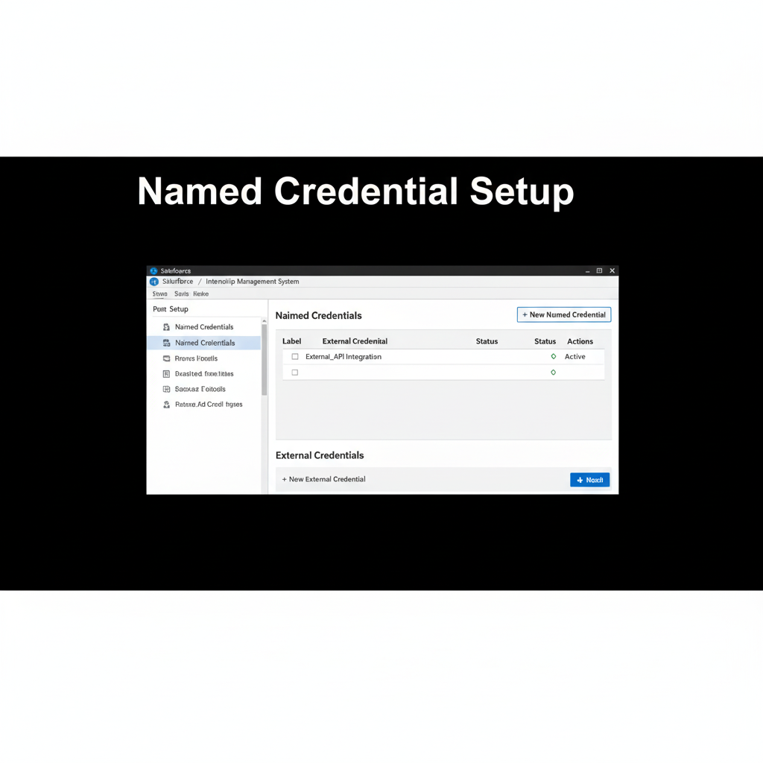

[REST API Integration Example]  
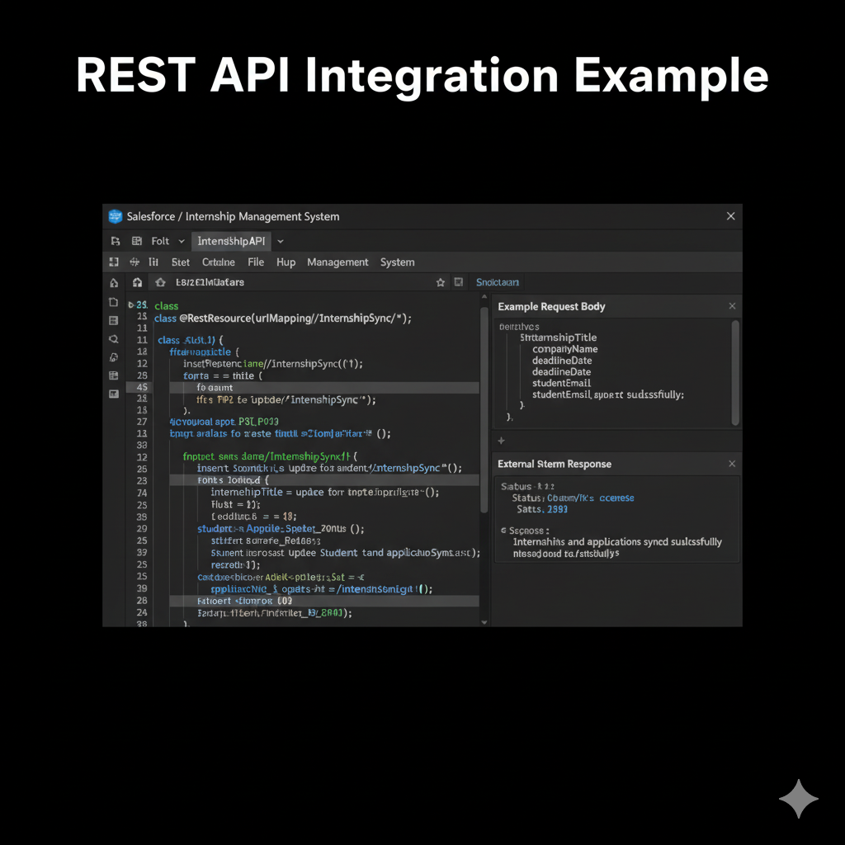

[Remote Site Settings]

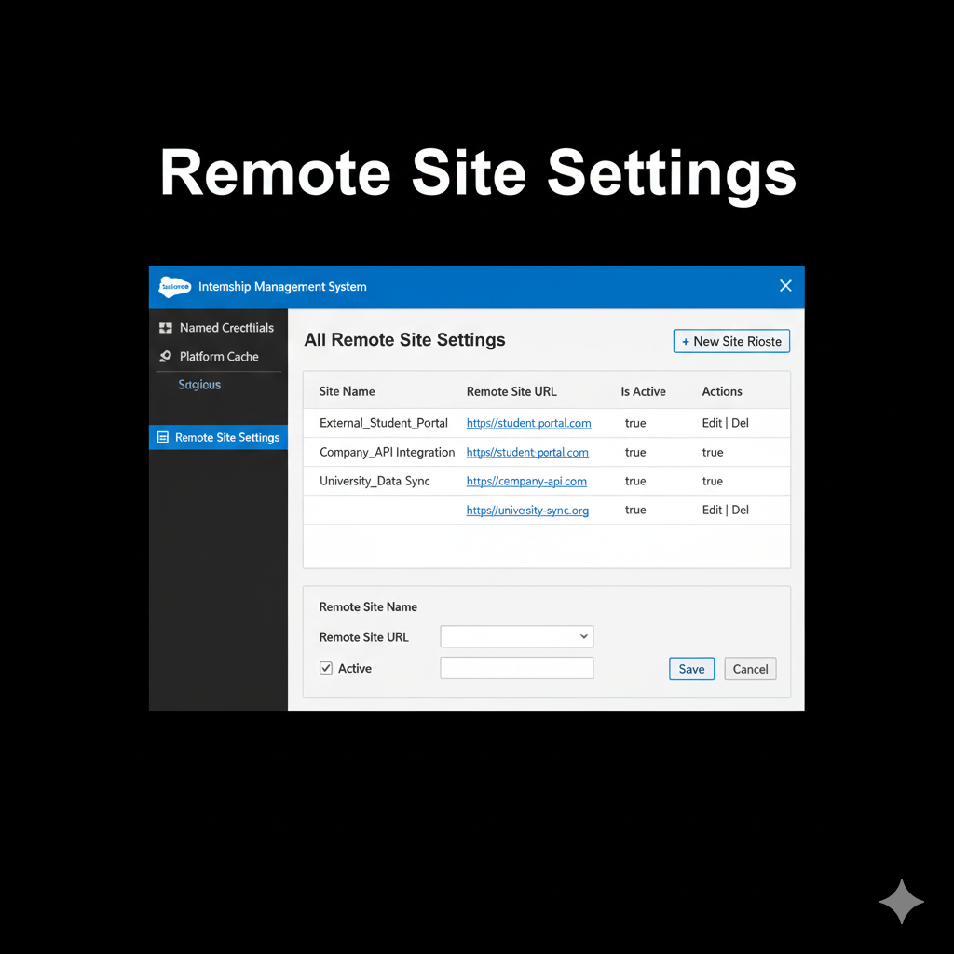

## Phase 8: Data Management & Deployment

- Data Import Wizard: Imported student and company records.  
- Duplicate Rules: Prevented duplicate company entries.  
- Change Sets: Used to deploy flows and triggers to production org.  
- Data Export: Scheduled weekly data backup for reports.

[Data Import Wizard]

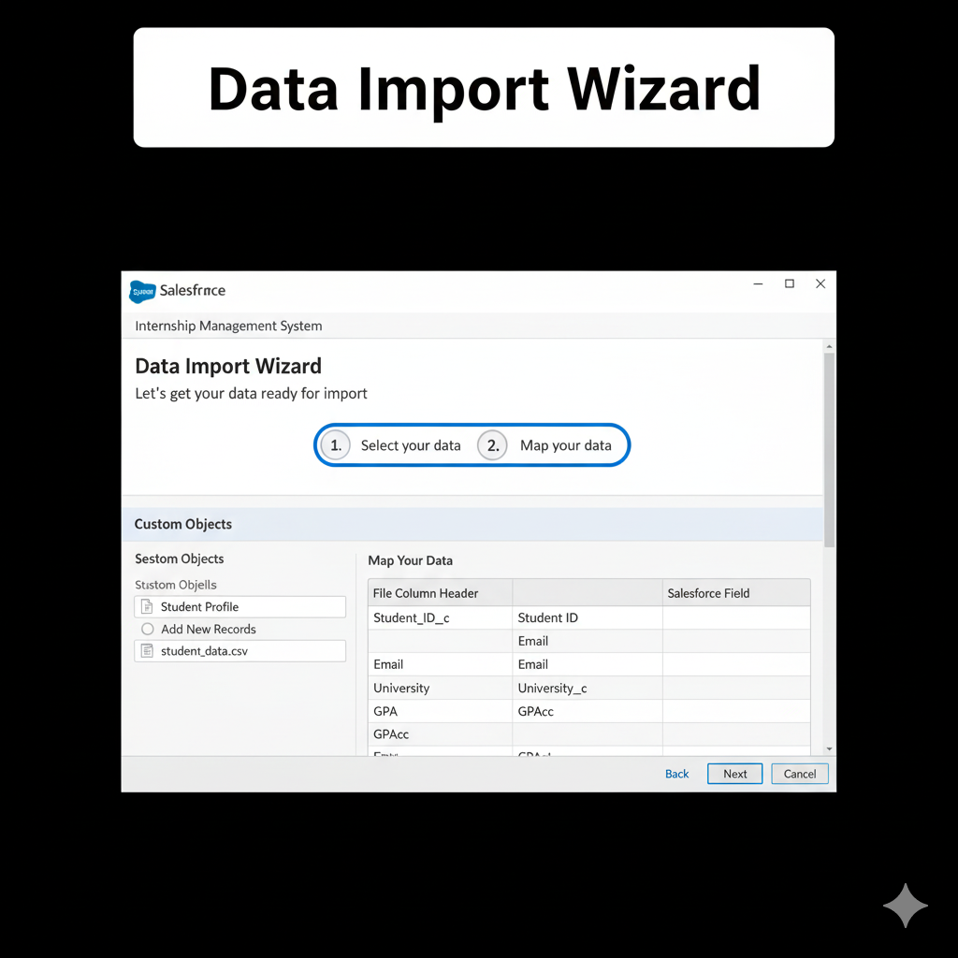

[Duplicate Rule Configuration]

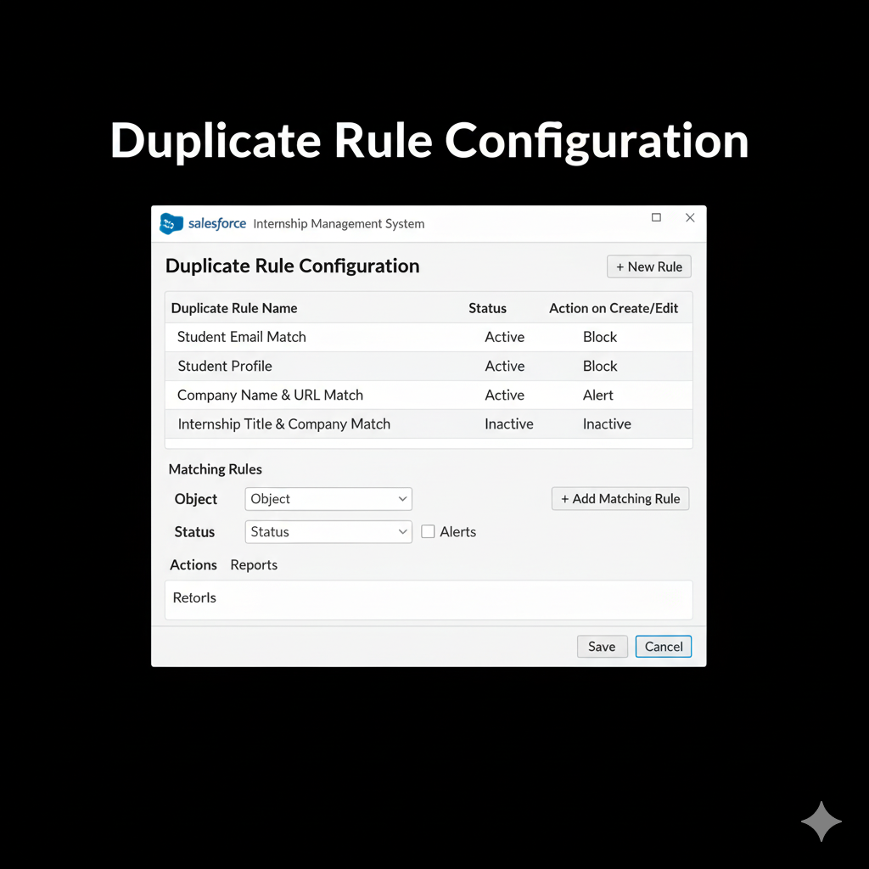

[Change Set Deployment]

## 

## Phase 9: Reporting, Dashboards & Security Review

- Reports:  
 - Applications per Internship (Summary Report)  
 - Student Placement Report (Matrix Report)  
- Dashboards:  
 - Coordinator Dashboard showing approved vs pending applications.  
 - Student Dashboard showing internship completion rates.  
- Profiles & Permission Sets:  
 - Restricted access: Students can view only their applications.  
 - Coordinators can view all records.  
- Sharing Rules: Based on Department.  
- Audit Trail: Enabled to track configuration changes.  
  
[Reports Overview]

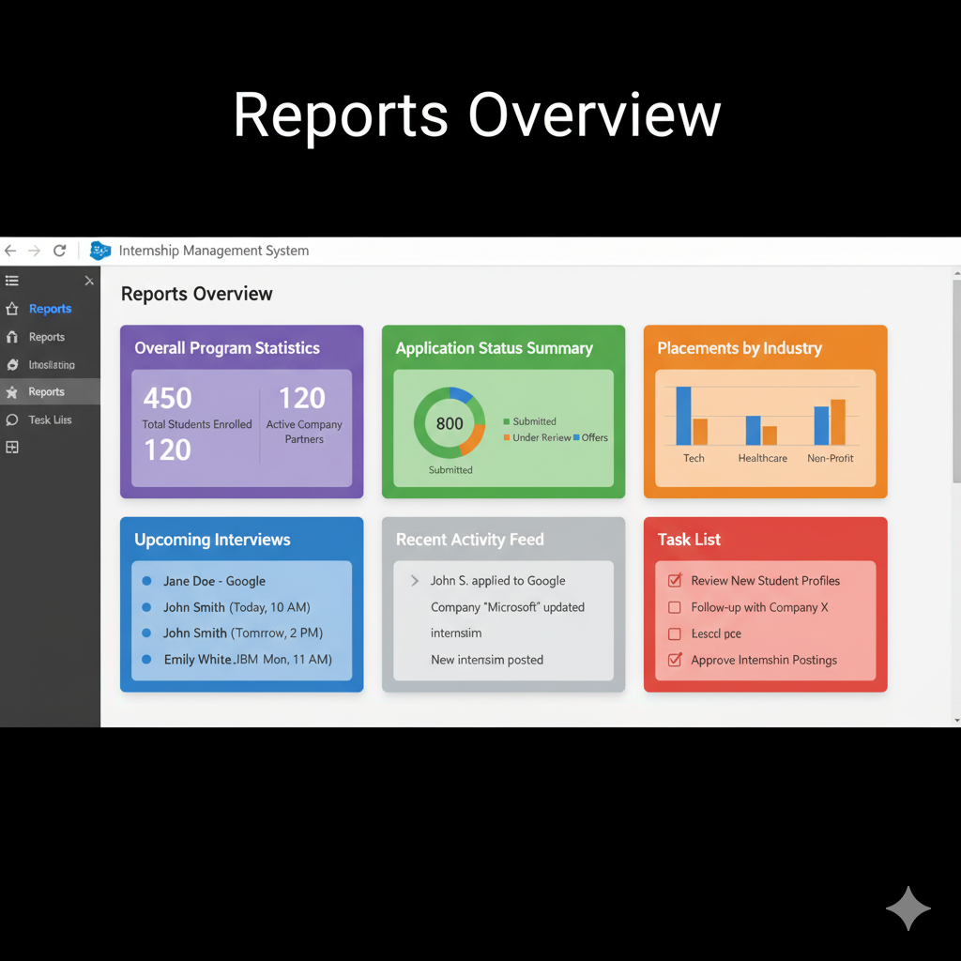

[Dashboard View]

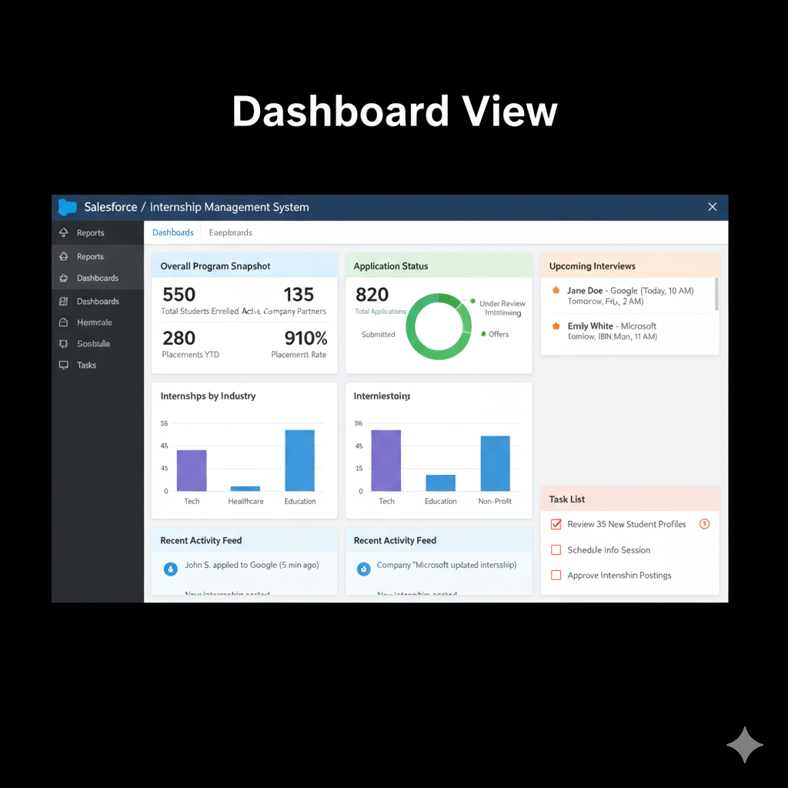

[Profiles and Permissions Setup]

## 

## Phase 10: Quality Assurance Testing

Test Case Example:  
  
| Use Case | Input | Expected Output | Actual Output | Result |  
|-----------|--------|-----------------|----------------|---------|  
| Student submits application | GPA=8.0 | Application saved | Application saved successfully | ✅ |  
| Coordinator approval | Click Approve | Status changes to “Approved” | Status changed to “Approved” | ✅ |  
| Company evaluation | Submit form | Student status “Completed” | Student status updated | ✅ |  
  
Testing covered flows, triggers, validation rules, and reports with screenshots of results.  
  
[Test Case Execution Result]

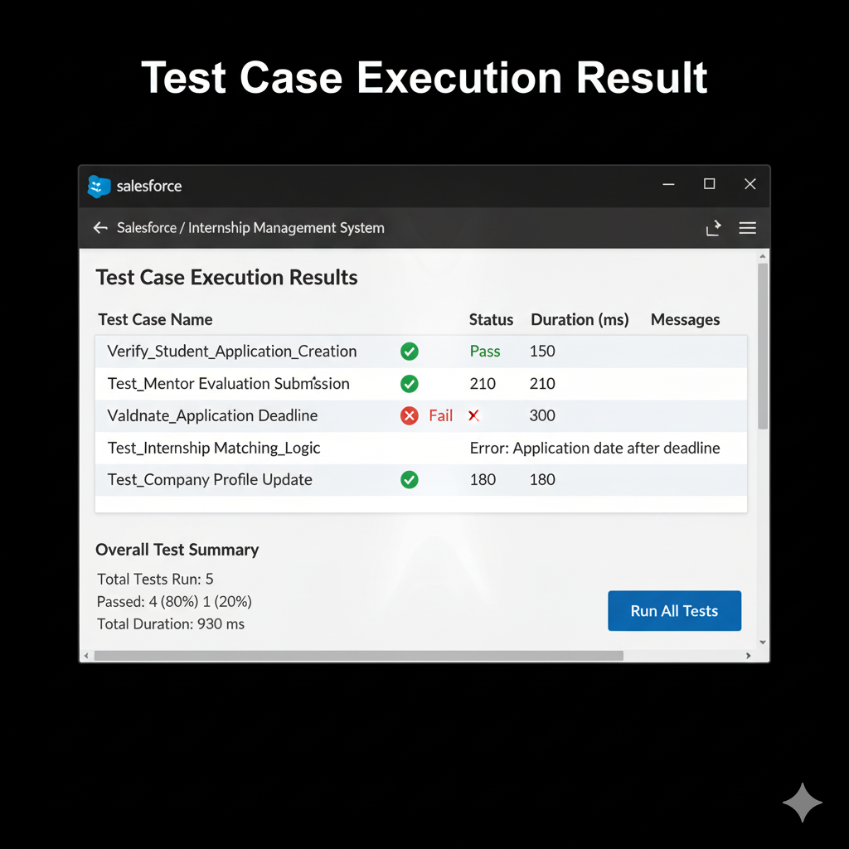

[Validation Test Output]

## 

## Conclusion

The Student Internship Management System successfully automates the end-to-end internship process on Salesforce. It reduces manual workload, enhances transparency, and improves coordination between institutions and companies. The CRM solution provides insightful dashboards for decision-making and sets a foundation for future enhancements such as AI-based internship matching and chatbot support for student queries.

[Final Dashboard or Summary Page]

